A FREE GUIDE FROM
[PRACTICE NAME]
The Desk Worker's Survival Guide
9 ways to undo the damage of sitting all day
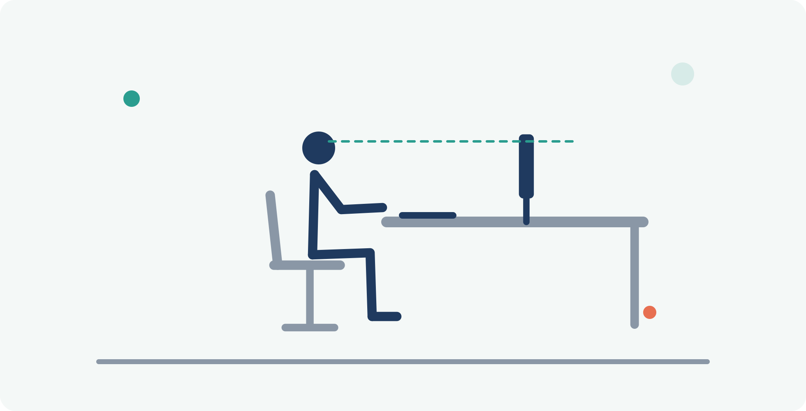
INSIDE THIS GUIDE
✓ A 60-second workstation check you can do right now
✓ The 30-minute rhythm that protects your spine
✓ 6 desk-friendly stretches with step-by-step pictures
✓ The warning signs that mean it's time to get checked

WHY THIS MATTERS

Your body wasn't built for 8 hours in a chair
If you work at a desk, you probably spend more time sitting than sleeping. Research consistently links prolonged sitting with neck pain, low-back pain, tension headaches, and tight hips — and most of us feel it long before we do anything about it: the stiff neck at 3 PM, the ache when you finally stand up, the shoulders that creep toward your ears during a deadline.
Here's the good news: the damage is not inevitable. Small, consistent changes to how you sit, how often you move, and how you reset your body make a measurable difference — usually within a couple of weeks.
This guide gives you 9 practical ways to fight back, in three groups: set up your space (ways 1–2), change your rhythm (way 3), and reset your body (ways 4–9). None of them require equipment, and every stretch fits into a two-minute break.
How to use this guide: start with the workstation check on the next page — it takes one minute. Then pick just two or three of the stretches and do them daily. Consistency beats intensity every time.

1 Run the 60-second workstation check
Most desk pain starts with a setup that forces your body into awkward positions for hours. Compare your desk to this picture right now — each label is one fix:
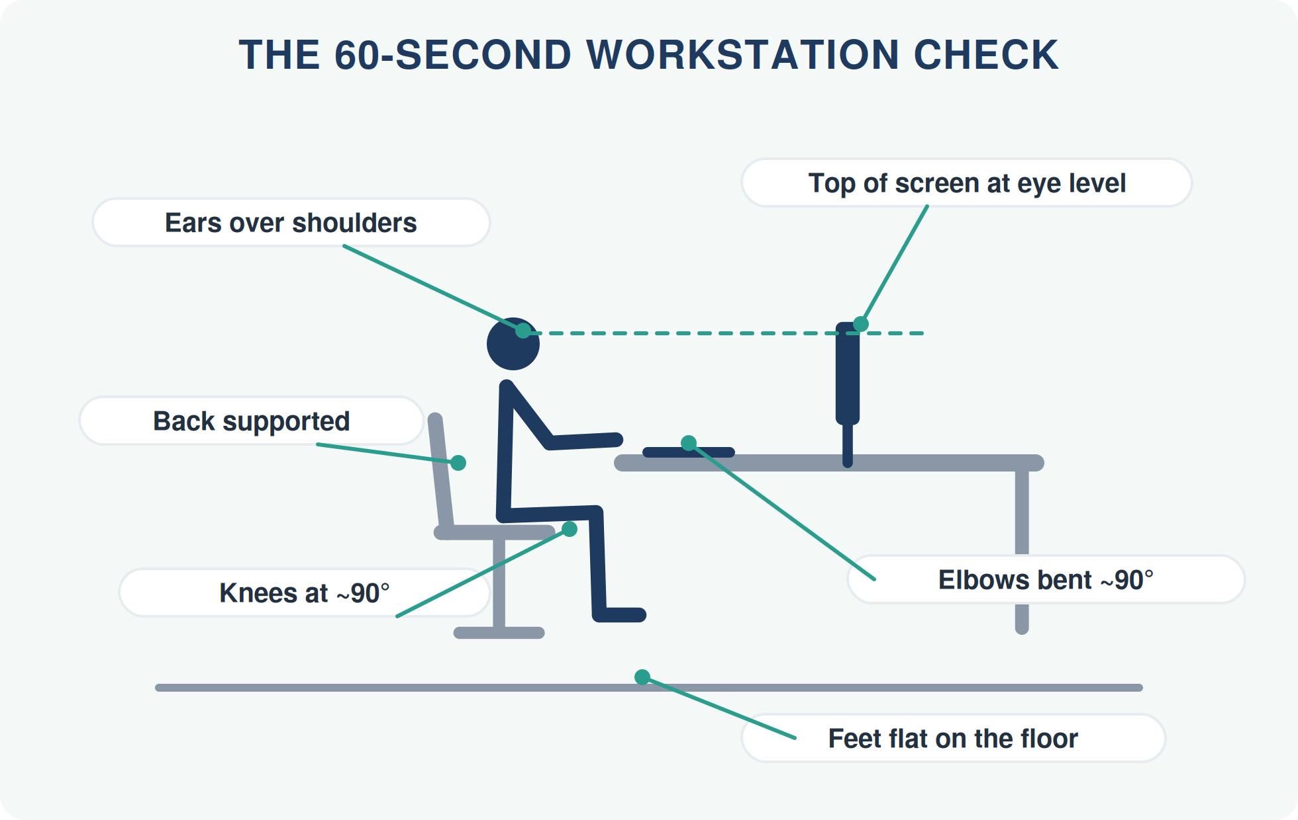
- Top of screen at eye level. If you look down at a laptop all day, your neck carries your head like a bowling ball held away from your body. Raise the screen on books or a stand, and add an external keyboard.
- Elbows at roughly 90°, shoulders relaxed — raise or lower your chair until your forearms rest level with the desk.
- Back supported. Sit back into the chair so the backrest does its job; a small cushion in the low-back curve helps.
- Feet flat on the floor, knees at about 90°. If your feet dangle, use a footrest or a sturdy box.

2 Sit supported — not 'perfectly straight'
Forget rigid 'sit up straight' posture. Your best sitting position is a supported, stacked one — and your second-best posture is simply your next one. The real enemy is the slow slump that creeps in after 20 minutes:
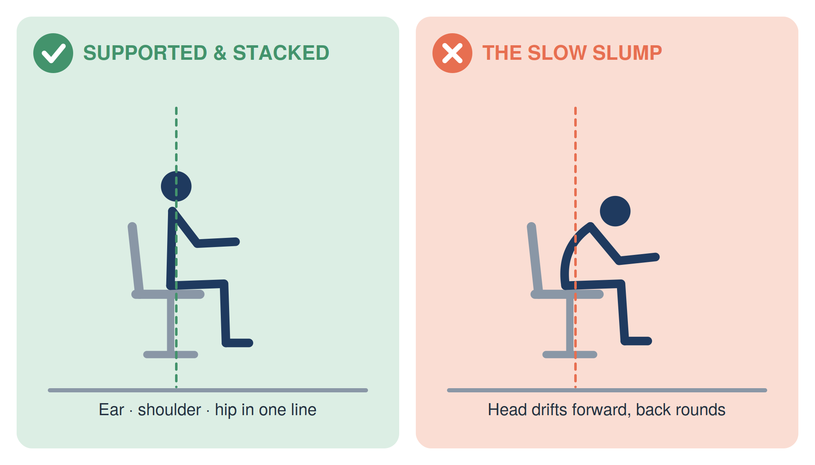
The 3 PM trick: set a recurring afternoon reminder that just says "ears over shoulders." That single cue undoes the forward-head drift that causes most desk-related neck tension and headaches.

3 Adopt the 30-minute rhythm
Even a perfect setup can't fix sitting still for too long. Your spinal discs have no direct blood supply — they rely on movement to stay nourished. Ergonomics researchers suggest a simple cycle:
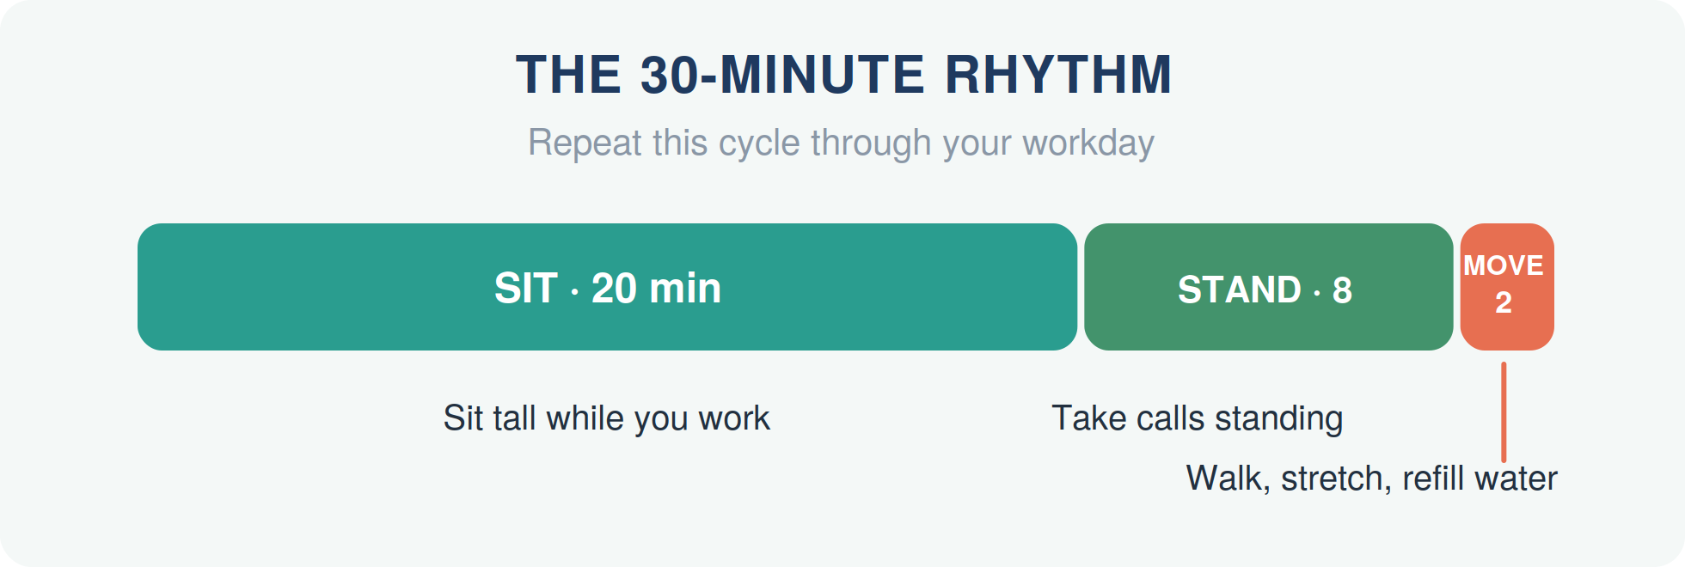
It sounds like a lot of interruption, but it isn't: stand while you take a call, walk to refill your water, stretch while a file loads. The movement minutes add up without costing you focus — most people find they concentrate better.

WAYS 4–9

The 6-stretch desk reset
Do these in order and the full circuit takes under five minutes. Move gently into each position — you should feel a comfortable stretch, never pain. Breathe slowly throughout; don't bounce or force anything.

4 Chin tucks — undo 'tech neck'
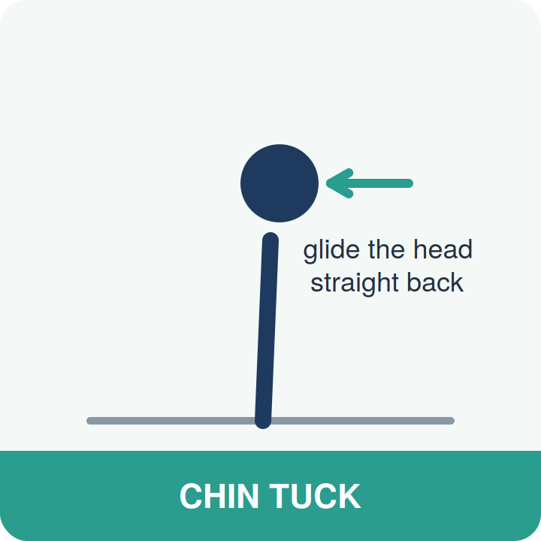
How: Sit or stand tall. Without tilting your head, glide it straight back — as if making a gentle double chin. Hold 3 seconds, relax, and repeat 10 times.
Why it works: Counteracts the forward-head position and reactivates the deep neck muscles that keep your head balanced over your spine.

5 Upper trap stretch — melt tight shoulders
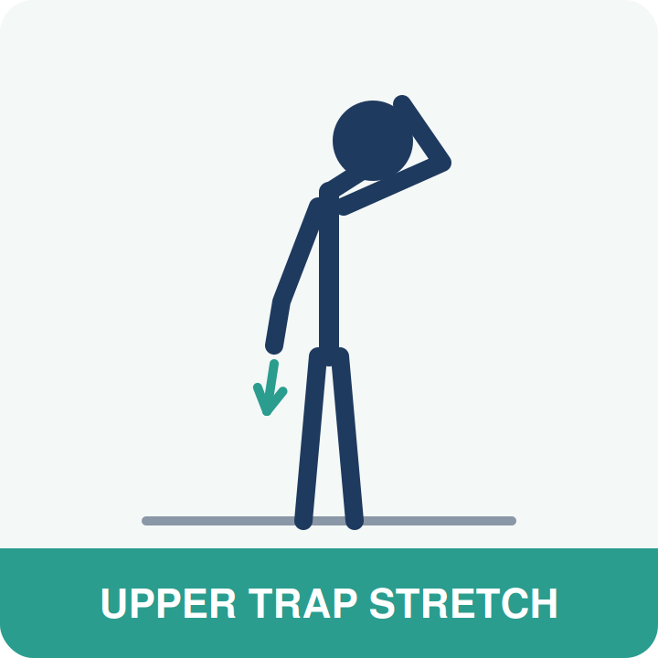
How: Sitting tall, let one ear drift toward the same-side shoulder. Rest the opposite hand behind your back or reach it gently toward the floor. Hold 20–30 seconds per side.
Why it works: Targets the muscles between your neck and shoulders — the ones that turn into 'stress rocks' during a deadline.

6 Doorway chest stretch — open up
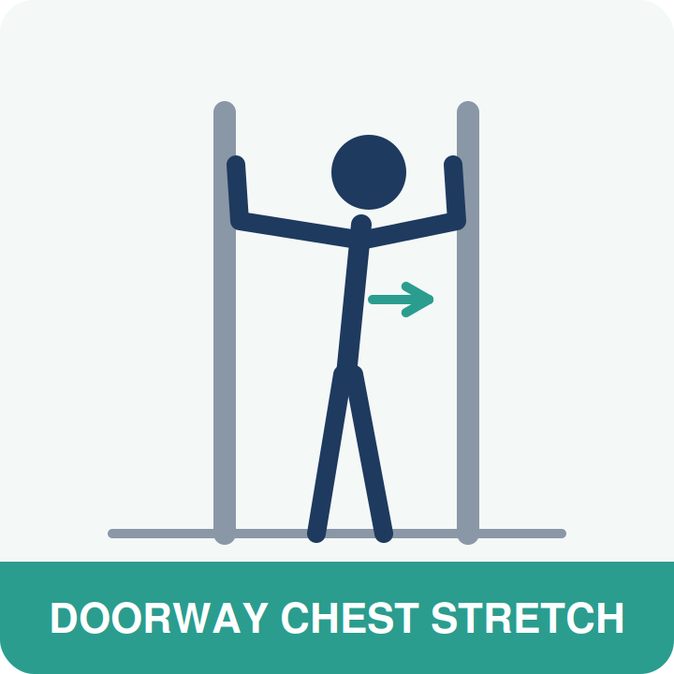
How: Stand in a doorway, forearms on the frame, elbows just below shoulder height. Step one foot forward until you feel a stretch across the chest. Hold 20–30 seconds.
Why it works: Hours of reaching forward to a keyboard shortens the chest muscles and rounds the shoulders. This reverses it.

7 Seated spinal twist — restore rotation
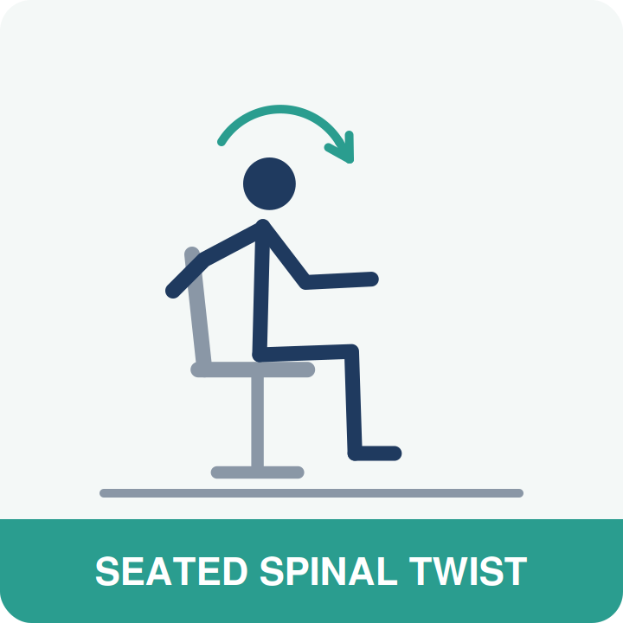
How: Sit sideways-on or tall in your chair, feet planted. Place one hand on the opposite knee or the chair back and rotate your upper body slowly, looking over the shoulder. Hold 15–20 seconds per side.
Why it works: Your mid-back is built to rotate. Sitting takes that motion away, and neighbouring joints pay the price.

8 Hip flexor lunge — release the sitting muscles
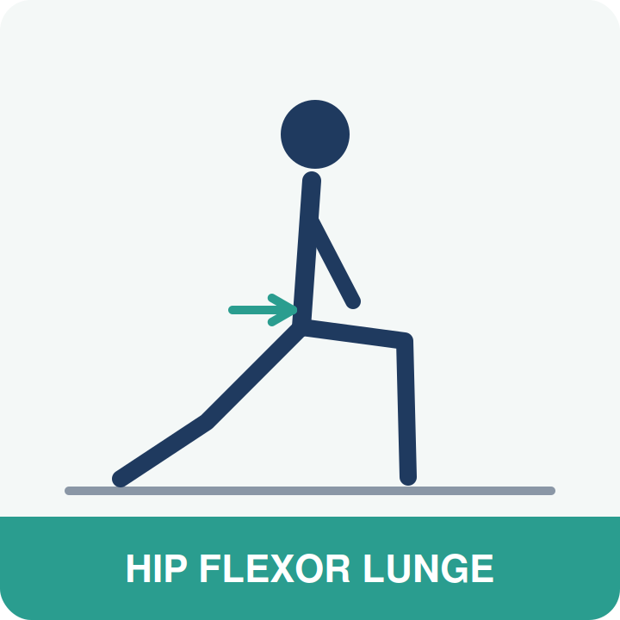
How: Take a half-kneeling position (back knee on a cushion). Tuck your tailbone slightly and shift your weight forward until you feel a stretch across the front of the back hip. Hold 20–30 seconds per side.
Why it works: The hip flexors adapt to a shortened position when you sit, then tug your pelvis forward when you stand — a common hidden driver of low-back ache.

9 Stand & reach reset — your hourly full stop
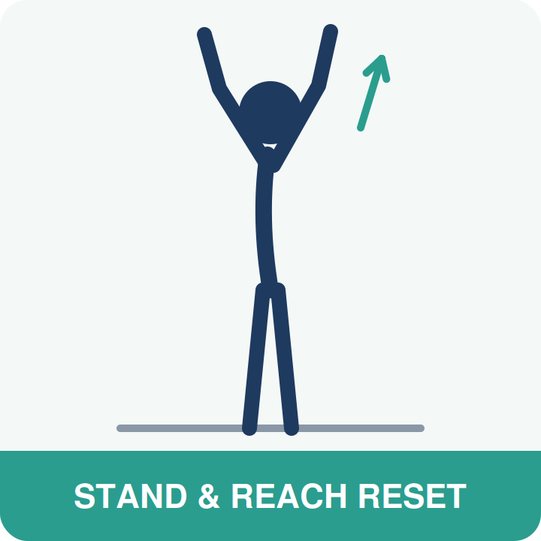
How: Stand up, interlace your fingers, and reach both palms toward the ceiling. Look slightly up, breathe in deeply, lean a touch back, and exhale slowly. Repeat 3 times.
Why it works: A 20-second full-body reset that re-extends everything sitting flexes. Do it every time you stand up and it becomes automatic.

AN HONEST NOTE

When stretching isn't enough
These nine strategies genuinely help most desk workers — but they work on the muscles and habits, not on underlying joint problems. If you notice any of the following, self-care alone is probably not the answer:
- Pain that has lasted more than two weeks despite better habits
- Neck or back pain that keeps returning in the same spot
- Headaches that start at the base of the skull and creep forward
- Numbness, tingling, or weakness in your arms or hands
- Pain that wakes you at night or is worse first thing in the morning
None of these mean something serious is wrong — but they do mean your body is compensating for something a stretch can't reach. A chiropractic assessment can identify which joints aren't moving well and build a plan that fixes causes instead of chasing symptoms.

YOUR NEXT STEP
Sit better. Feel better. Get checked.
You've got the tools — and if your body is telling you it needs more than stretches, we're here to listen. Book a no-pressure assessment and find out exactly what's driving your desk-day aches.
READER OFFER
[Special Offer — e.g., a complimentary posture & spine check for new patients who mention this guide]
Mention this guide when you book.

[PRACTICE NAME]
📞 [Phone Number]
🌐 [Website / Online Booking Link]
📍 [Street Address, City]
🕐 [Opening Hours]

Medical disclaimer
This guide ("The Desk Worker's Survival Guide") is provided for general educational purposes only and is not a substitute for professional diagnosis, advice, or treatment. Always consult a qualified healthcare provider about your individual situation before starting new exercises or self-care routines. If you experience severe pain, numbness, weakness, or any of the red-flag symptoms described in this guide, seek professional care promptly. © [Year] [Practice Name]. You are welcome to share this guide in its complete, unmodified form.

